**Activity: Preparing a simple workspace**

**Introduction**

As a data analyst at Adventure Works, your focus is on extracting valuable insights from a large variety of data to aid strategic decision-making related to sales, marketing, orders, and potential areas of growth. Microsoft Power BI is a tool you can use to sort, organize, and analyze this vast information. In particular, Power BI Workspaces empower you to efficiently create compartments to store, access, share, and analyze different types of data.

In this step-by-step activity, you will learn how to create a simple workspace in Power BI. This is in preparation for the next exercise, where you will build your own dashboard. Creating dashboards within a workspace allows for more efficient content management, organization, and collaboration.

**Power BI workspaces**

A workspace in Power BI is a dedicated container or space that holds various components such as dashboards, reports, workbooks, and datasets. Consider the specific folders you might create for different projects or tasks on your desktop to keep things organized and easily accessible. A Power BI workspace is like your personal project folder. However, instead of Word documents or Excel files, it's your powerhouse of data assets, making it easy to organize and access these assets. A workspace is an exclusive zone where you can store, manage, and work on data-related components.

Creating a workspace in Power BI isn't just an elementary step—it's the core foundation of your data management strategy. Like your project folders, workspaces allow you to group related content together. Whether handling datasets, creating reports, or sharing insights, having an organized space makes your tasks easier to manage. Consider Adventure Works as an example. It's a large organization with multiple departments, each with its own set of data requirements. Adventure Works might create separate workspaces for their Sales, Human Resources, Manufacturing, and Marketing departments. This allows them to keep the data related to these departments separate, organized, and tailored to their specific needs. Now, let's dive into how you can create a workspace in Power BI.

**Creating a workspace in Power BI**

**Step 1: Locate workspaces**

1. Once successfully logged into the Power BI Service, locate the vertical navigation bar on the left side. This is your magic panel that houses various options.
2. Among these options, find and select **Workspaces**. The icon resembles multiple windows stacked upon each other, symbolizing collective collaboration.

**Note:** All your current and future workspaces reside in the **Workspaces** pane. You can think of it as a command center that provides a birds-eye view to manage all your workspaces.

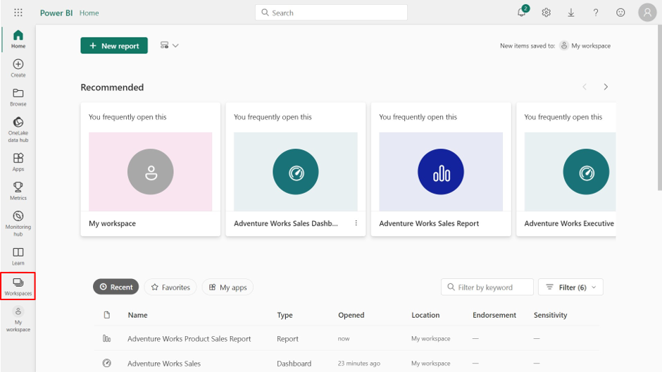

**Step 2: Create a workspace**

* Select the **+ New workspace** button on the bottom left corner of the open **Workspaces** pane. This button is your starting point for creating a new workspace.

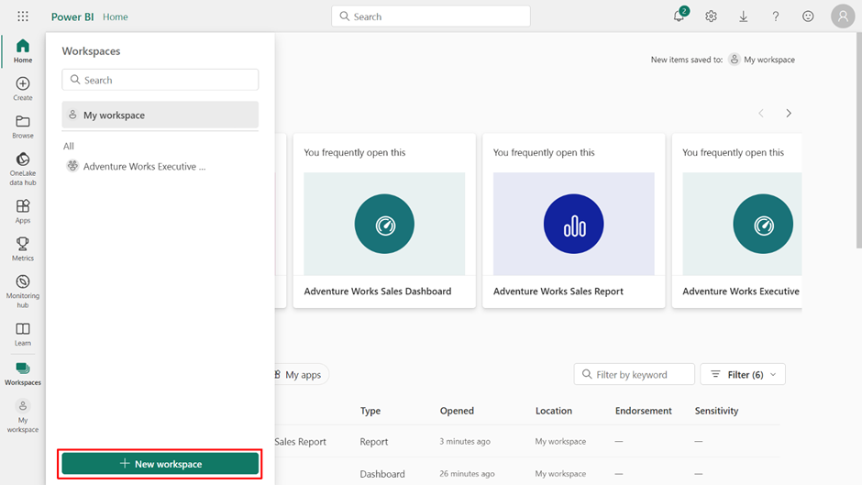

**Step 3: Name your workspace**

As you select the **+ New workspace** button, a **Create a workspace** window opens on the right side of your screen.

* In the **Name** field, enter the title of your workspace. For example, name the workspace *Adventure Works* as you're creating this workspace for the general analysis of multiple datasets like **Product Sales**, **Customers**, and **Orders**.

**Note:** The **Name** field is the first field in the **Create a workspace** window. Think of this as the identity card of your workspace. Each workspace you create has to have a unique, meaningful, and distinct name, as this will be its primary identifier within the Power BI ecosystem. As a result, the name you choose should be intuitive and reflective of the workspace's purpose or the data it holds.

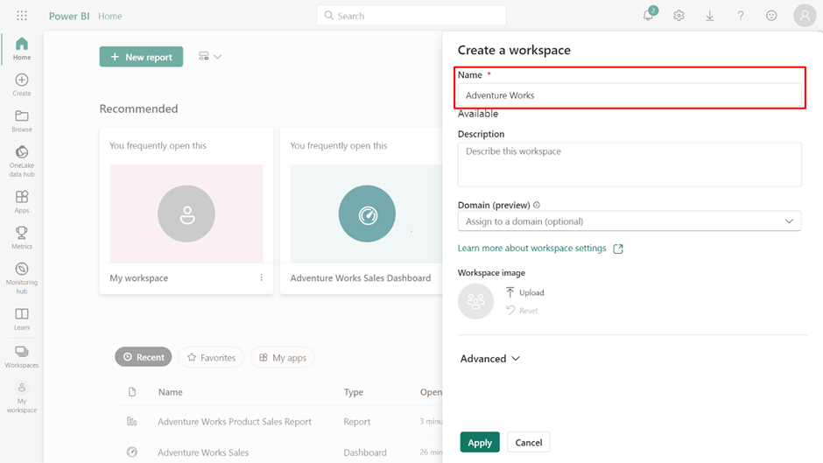

**Step 4: Describe your workspace**

1. Locate the **Description** box below the **Name** field.
2. In the **Description** field, enter **This workspace houses data for Adventure Works' analysis of Product Sales, Customers, and Orders**.

**Note:** Describing your workspace is like laying the foundation of a building. It allows you to brief everyone about the workspace's purpose, what it houses, or what project or department it caters to. While the description is optional, it's highly recommended to guide any future users who may come across your workspace.

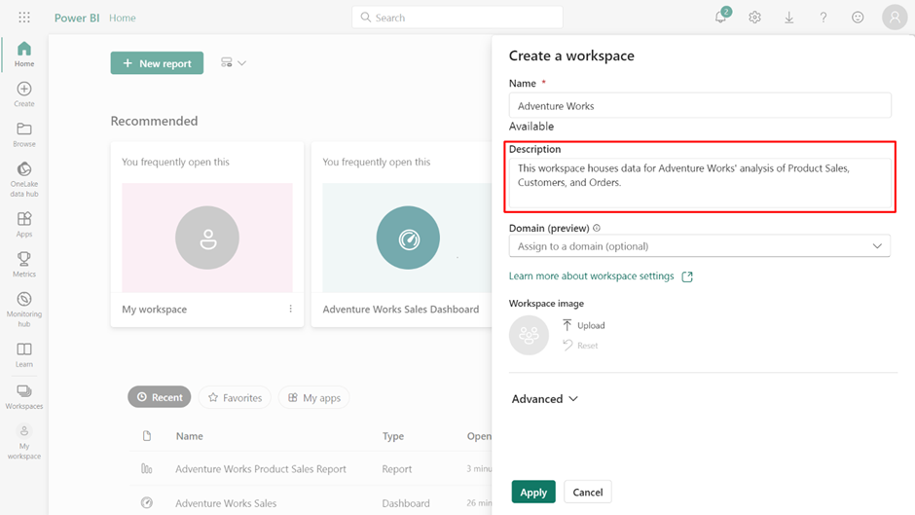

**Step 5: Workspace contact settings**

1. Scroll further down the **Create a workspace** window and expand the **Advanced** menu.
2. Identify the **Contact list** section. **Note:** This is an important setting where you define who gets contacted when there are questions or issues with the workspace's content.
3. In the **Contact list** section, check that your email address is listed. This default setting implies that, as the creator and owner of this workspace, you are the primary point of contact for any questions or issues concerning the workspace's content.
4. You can change this listing and specify additional users who can serve as contacts. **Note:** By adding additional contacts, you are decentralizing the communication process. This helps when you need to distribute responsibility or ensure that questions and issues are directed to the most suitable person.

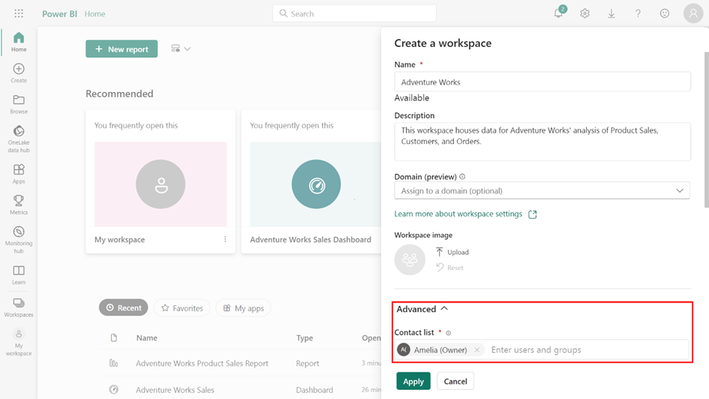

**Step 6: Finalize workspace creation**

Once you've fine-tuned the contact settings, the next step is to create the workspace.

* At the bottom of the **Create a workspace** window, select **Apply** to finalize the creation process. Once you select this, all the details you have entered and adjusted take effect.

**Note:** You can modify each workspace as per your evolving needs. You can add or remove members, adjust their roles, or change workspace settings even after you've created it.

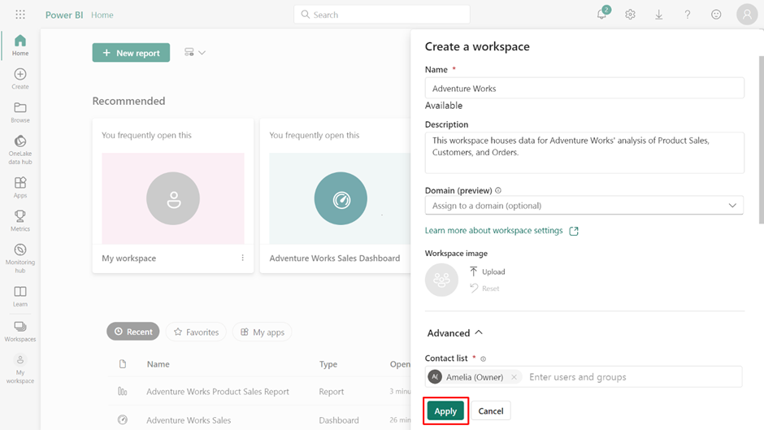

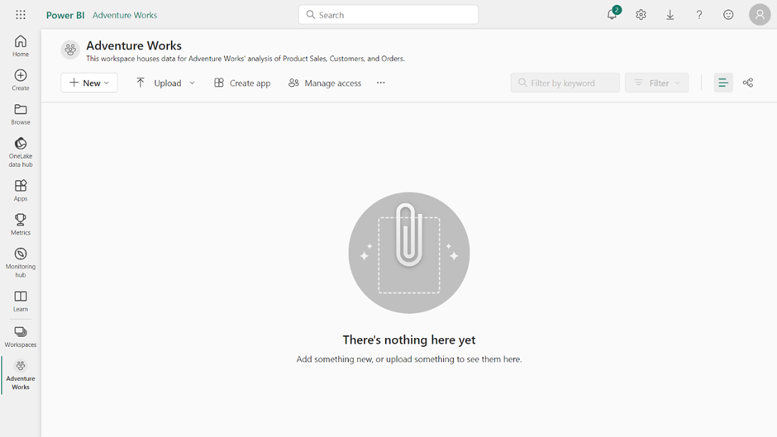

**Conclusion**

And there you have it—the creation of your first workspace in Power BI service. Each workspace you create in Power BI is like a chapter in the story of your data analysis journey. While this reading introduced you to creating a workspace in Power BI, you will explore workspaces in much greater depth in a later course. You are now prepared to build your own dashboard in the next exercise, using the workspace you created in this activity.